Report on
Unveiling The Virtual Classroom: An In-Depth Analysis of The Online Education
1. INTRODUCTION
1.1 Overview: Online classes and technology have emerged as a superhero during the lockdown days. We have all been under house arrest but are still connected with the world of education. Due to the lockdown, students have not been able to stay connected with the outer world and the lack of exposure is evident. The only reprieve for the students’ mental well-being has been the transition to online classes. Teachers made sure that the learning for students was not compromised, so they took a great leap forward to find solutions and create new learning environments for their students to ensure that learning never stops. With the rapid advancements in technology and the widespread availability of internet access, online education has gained significant popularity in recent years.

1.2 Purpose: To delvelop deep into the various aspects of online education, examining its strengths, weaknesses, opportunities, and challenges. Online education system aims to contribute to the ongoing dialogue on the future of education and help shape a more inclusive, engaging, and effective learning environment in the digital age.
2 LITERATURE SURVEY
2.1 Existing problem
A literature survey for online education would involve reviewing existing research on topics related to ed tech and student behaviour. The survey would involve defining a research question, identifying relevant sources, reading and analysing the literature, organizing and summarizing the literature, identifying gaps in the literature, and providing recommendations for e-learning/online education based on the findings. The goal of the literature survey is to understand the current state of knowledge on a topic and to identify areas where further research is needed. It also helps to build upon the existing knowledge and avoid duplication of effort.
2.2 Proposed solution
A complete analysis of Online Education system which provides the students with the complete information and also the pros and cons of Online Education system. It also provides valuable insights to educational institutions, policymakers, and online learning platforms to enhance the effectiveness and accessibility of online education
3 THEORITICAL ANALYSIS
3.1 Block diagram
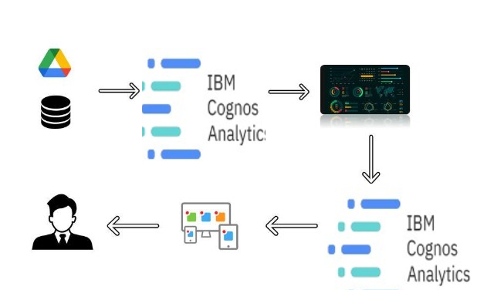

3.2 Hardware / Software designing
The Hardware required for this project is, we need a Personal Desktop computer/ Laptop and software requirements of this project are IBM COGNOS ANALYTICS, PYTHON, Web Framework like Flask or Django
4 EXPERIMENTAL INVESTIGATIONS
The following are few analysis or the investigation made while working on the solution.
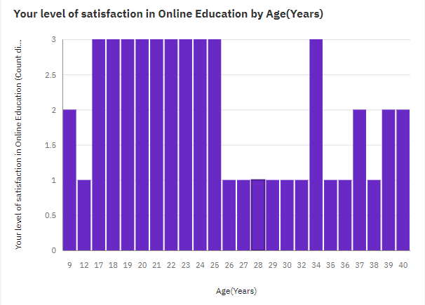

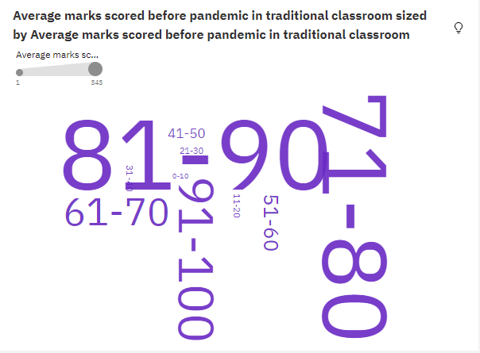
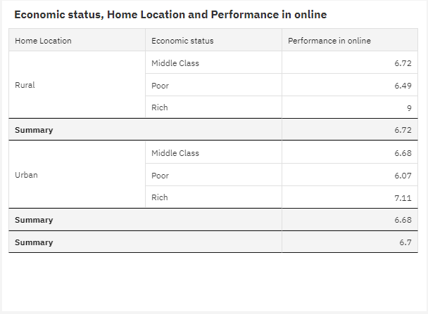
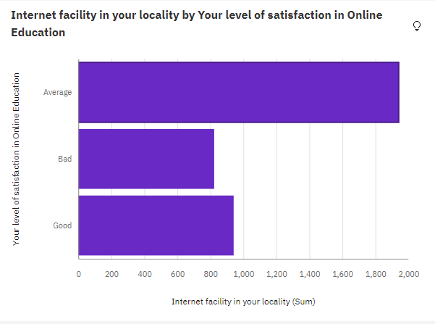
5. FLOWCHART
To accomplish this, I had completed all the activities below,

- Define Problem / Problem Understanding
  - Specify the business problem
  - Business requirements
  - Literature Survey
  - Social or Business Impact.
- Data Collection
  - Collect the dataset
  - Connect data with IBM cognos
- Data Preparation
- Prepare the Data for Visualization
- Data Visualizations
  - No of Unique Visualizations
- Dashboard
  - Responsive and Design of Dashboard
- Story
  - No of Scenes of Story
- Report
- Creating a report
- Performance Testing
  - Amount of Data Rendered to DB ‘
  - Utilization of Data Filters
  - No of Calculation Fields
  - No of Visualizations/ Graphs
- Web Integration
  - Dashboard and Story embed with UI With Flask
- Project Demonstration & Documentation
  - Record explanation Video for project end to end solution
  - Project Documentation-Step by step project development procedure

6. RESULTS
Initially, I had created a data source with the help of the given ONLINE EDUCATION SYSTEM REVIEW.csv file and also made data cleaning by rearranging some data. I had created visualizations with the help of the explorations using different features in the columns. I created a Dashboard with the help of visualizations and story with different scenes. Finally, I created a report on Online Education system.

Dashboard:

Story:

Report:

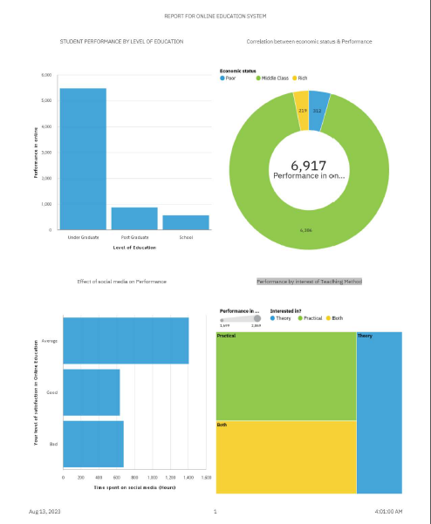

Finally using bootstrap template and Flask, I had created a web application by integrating my application with web.
Web Integration:
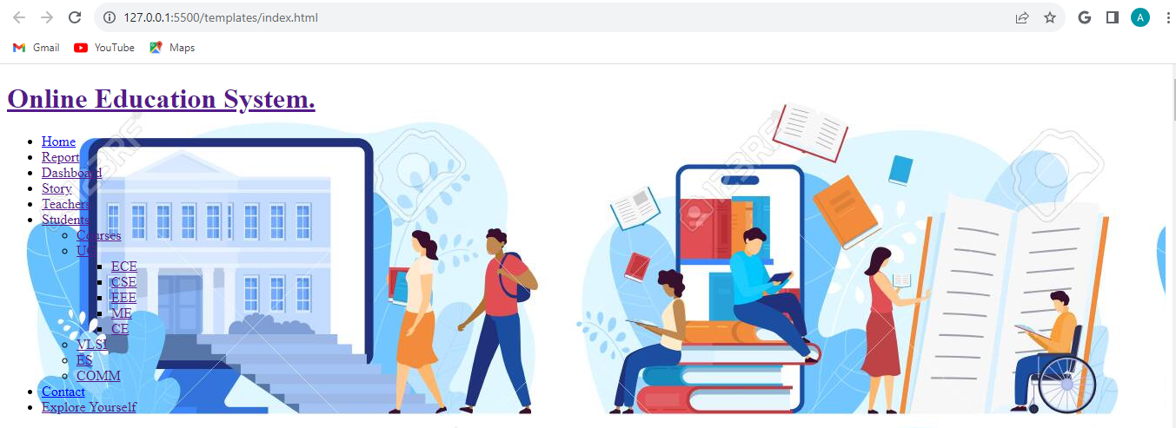
7. ADVANTAGES & DISADVANTAGES
Advantages of Online Education system are:
Flexibility and Convenience, Wide Range of Courses, Cost-Effectiveness, Personalized Learning, Diverse Learning Tools, Global Networking, Environmentally Friendly, Lifelong Learning Opportunities etc
Disadvantages of Online Education system are:
Lack of Face-to-Face Interaction, Technical Issues, Limited Practical Learning, Limited Soft Skills Development, Question of Quality, Limited Networking Opportunities etc

8. APPLICATIONS
Formal Education, Distance Learning, Skill Development and Vocational Training, Personalized Learning, Professional Development etc
9. CONCLUSION
In this problem we started taking student and teacher surveys, understanding student needs, and having an efficient feedback system. There is a need to update the content that is being taught to students based on the feedback. These requirements are necessary to ensure that students are able to find it easy to adjust with online education / e-learning. Specific requirements may vary depending on the student demographic, their needs and their interests A complete analysis of Online Education System helps the educational institutions, policymakers, and online learning platforms to enhance the effectiveness and accessibility of online education
10. FUTURE SCOPE
In future the analysis can be done still deeper by using various multiple features with more excited explorations which give a complete picture of Online Education System and similar kind of analysis can be done in various fields like agriculture, Global economic growth, Nutrition analysis and further.

11. BIBILOGRAPHY
Hodges, C., Moore, S., Lockee, B., Trust, T., & Bond, A. (2020). The difference between emergency remote teaching and online learning. EDUCAUSE Review.
Li, N., Marsh, G., & Rienties, B. (2016). Modelling and managing learner satisfaction: Use of learner feedback to enhance blended and online learning experience. Internet and Higher Education, 29, 68-74.
Dixson, M. D. (2015). Measuring student engagement in the online course: The Online Student Engagement Scale (OSE). Online Learning, 19(4).

APPENDIX A.
Source Code link:

